R PROGRAMMING
EXPERIMENT – 1 ADDITION:
AIM:
To prove the program for addition using R-tool.

PROGRAM:
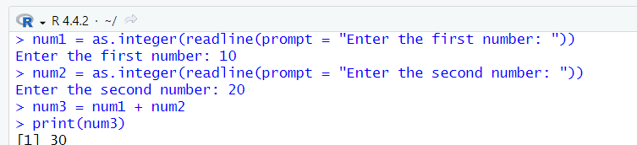

EXPERIMENT – 2 SUBTRACTIONS:
AIM:
To prove the program for subtraction using R-tool.

PROGRAM:
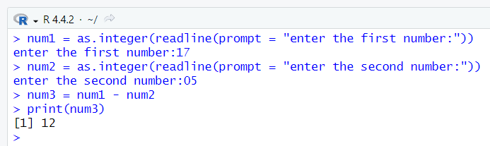

EXPERIMENT – 3 MULTIPLICATION:
AIM:
To prove the program for multiplication using R-tool.

PROGRAM:
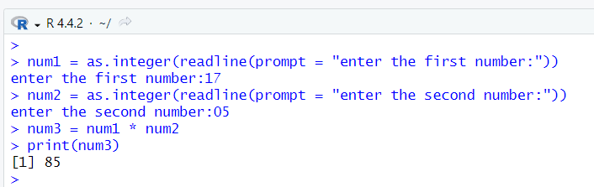

EXPERIMENT – 4 DIVISION:
AIM:
To prove the program for division using R-tool.

PROGRAM:
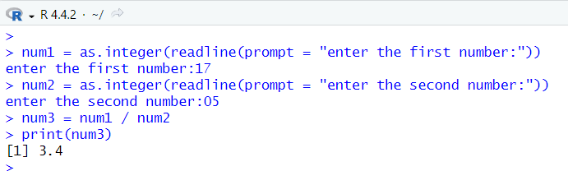

EXPERIMENT – 5 ODD OR EVEN:
AIM:
To write the program for odd or even using R-tool.
PROGRAM:
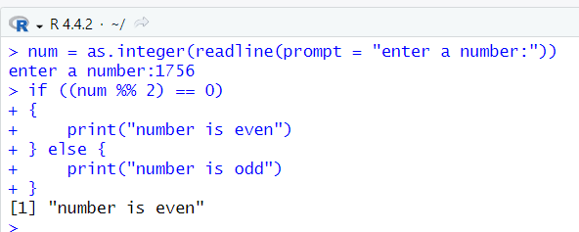
EXPERIMENT – 6 MEAN,MEDIAN,MODE:
AIM:
To write the program for mean,median,mode.
PROGRAM:
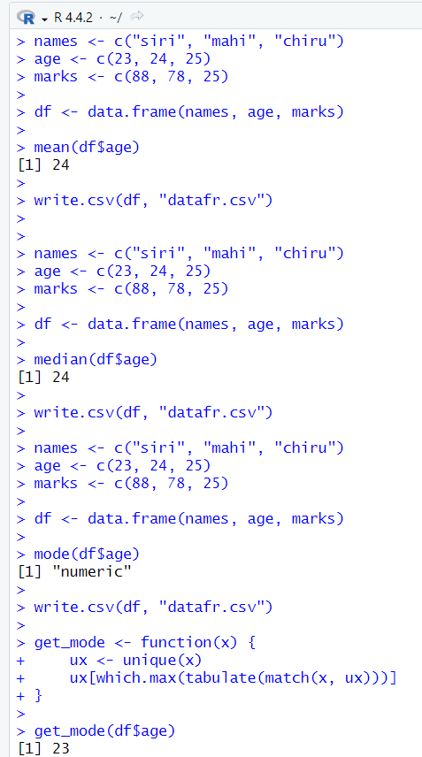
EXPERIMENT – 7 SUMMARY:
AIM:
To write the program for summary using R-tool.

PROGRAM:
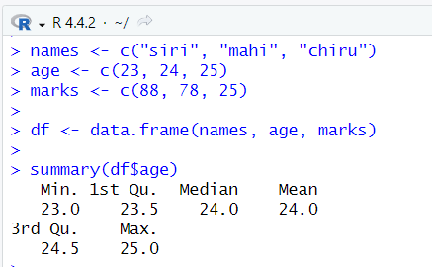

EXPERIMENT – 8 GREATER AMONG THREE NUMBERS:
AIM:
To write the program for the greatest among three numbers.

PROGRAM:
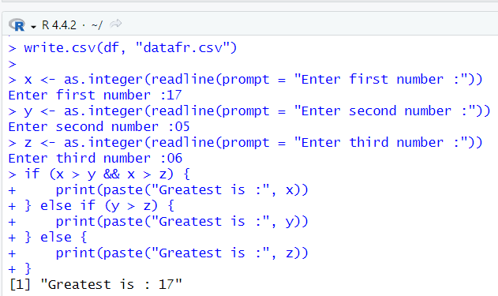
EXPERIMENT – 9 IQR:
AIM:
To write the program for central tendency and data dispersion measures using R tool.

PROGRAM:
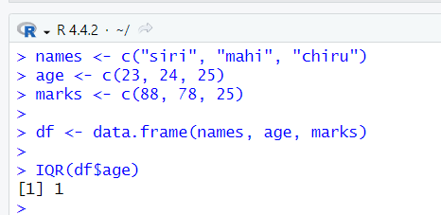

EXPERIMENT – 10 QUANTILE:
AIM:
To write the program for central tendency and data dispersion measures.

PROGRAM:
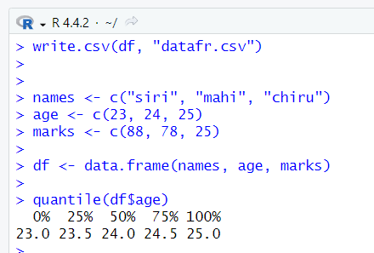

EXPERIMENT – 11 MID RANGE:
AIM:
To write the program for central tendency and data dispersion measures.

PROGRAM:
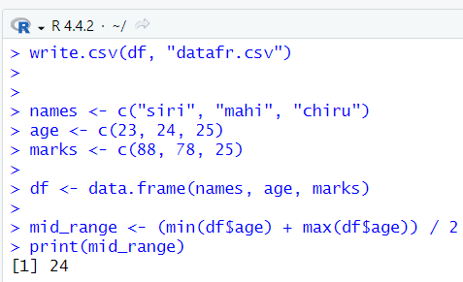
EXPERIMENT – 12 Z-SCOORE NORMALIZATION:
AIM:
To write the program for Z-scoore normalization using R-tool.
PROGRAM:
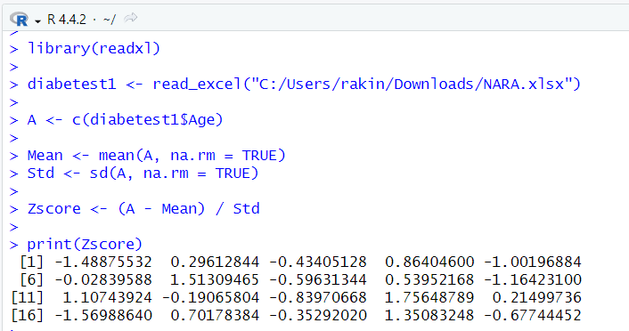
EXPERIMENT – 13 MIN,MAX,MEAN,MINMAX:
AIM:
To write the program for the minimum,maximum,mean and minmax using r-TOOL

PROGRAM:
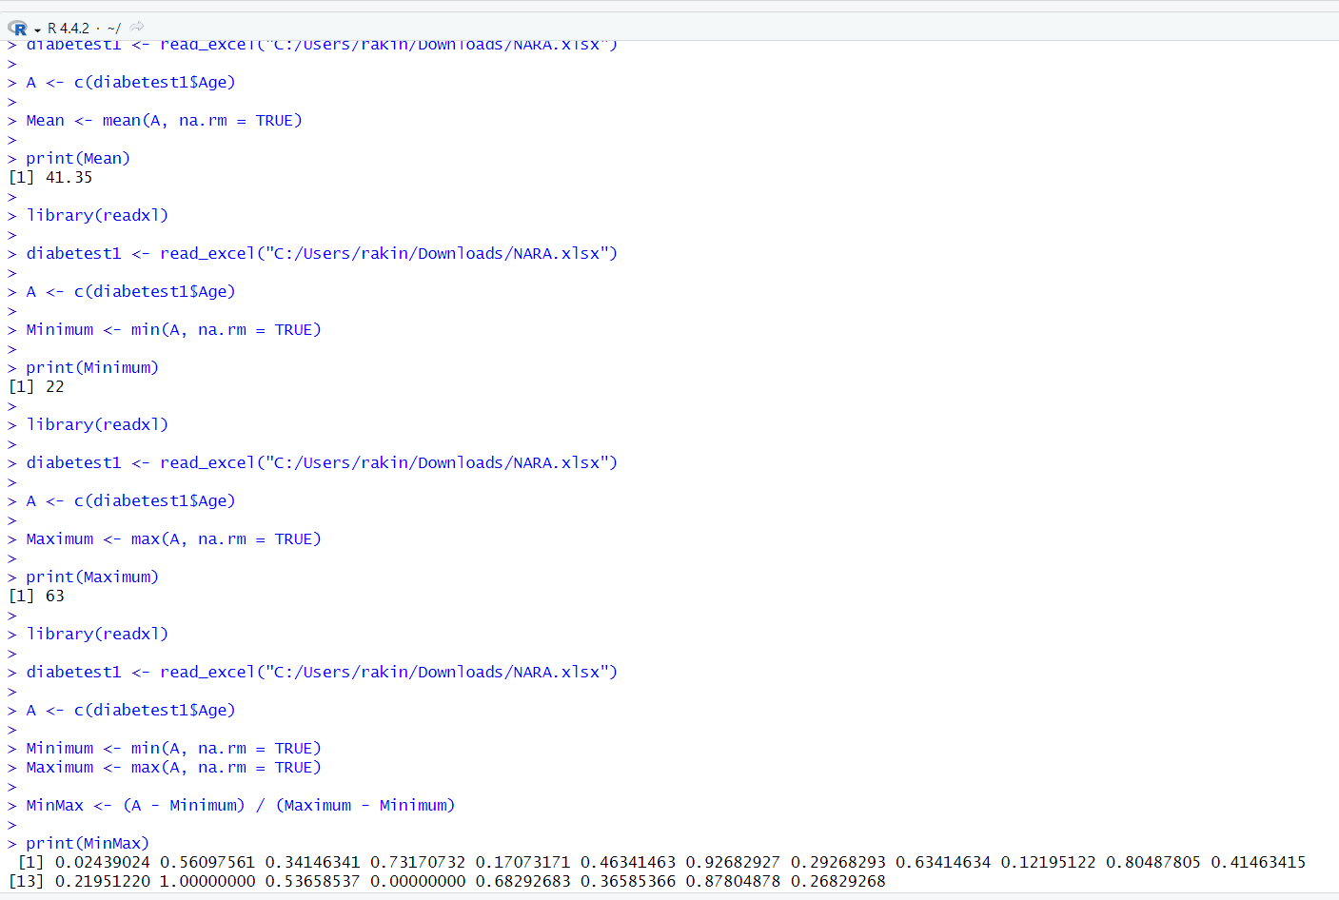

EXPERIMENT – 14 BAR PLOT AND HORIZONTAL BAR:
AIM:
To draw the bar plot and horizontal bar using R-tool.

PROGRAM:
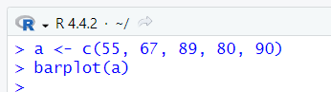
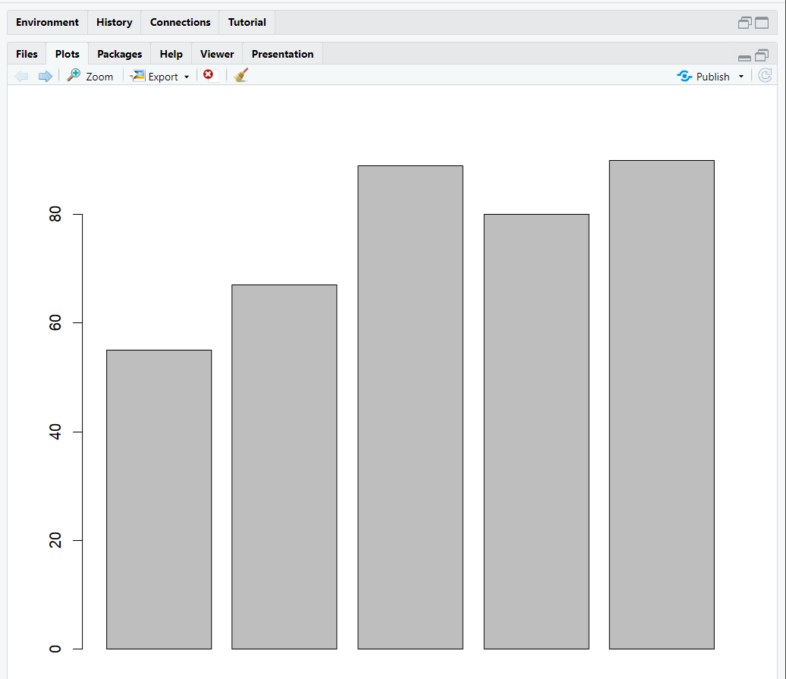

EXPERIMENT – 15 BOX PLOT
AIM:
To draw a box plot using R-tool.
PROGRAM:
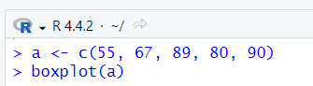
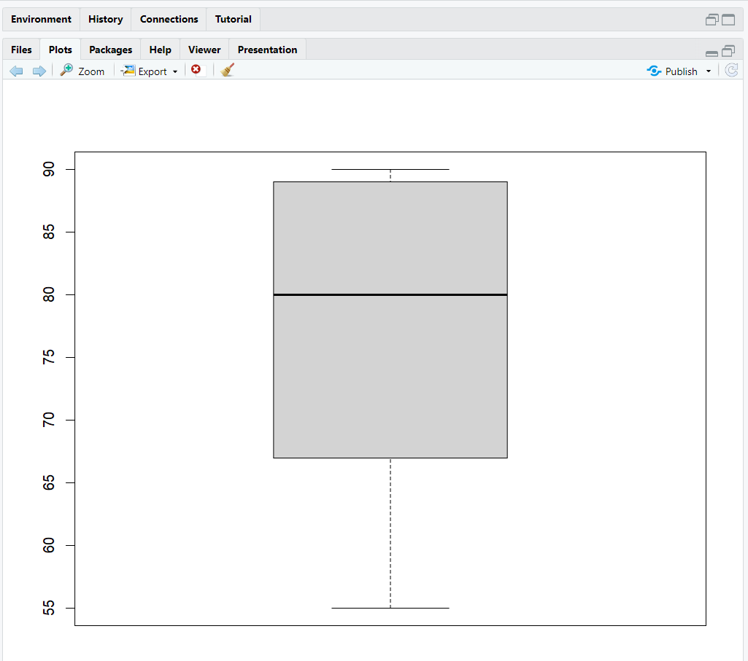

EXPERIMENT – 16 HISTOGRAM
AIM:
To draw a histogram plot using R-tool.

PROGRAM:
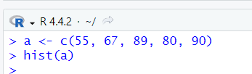
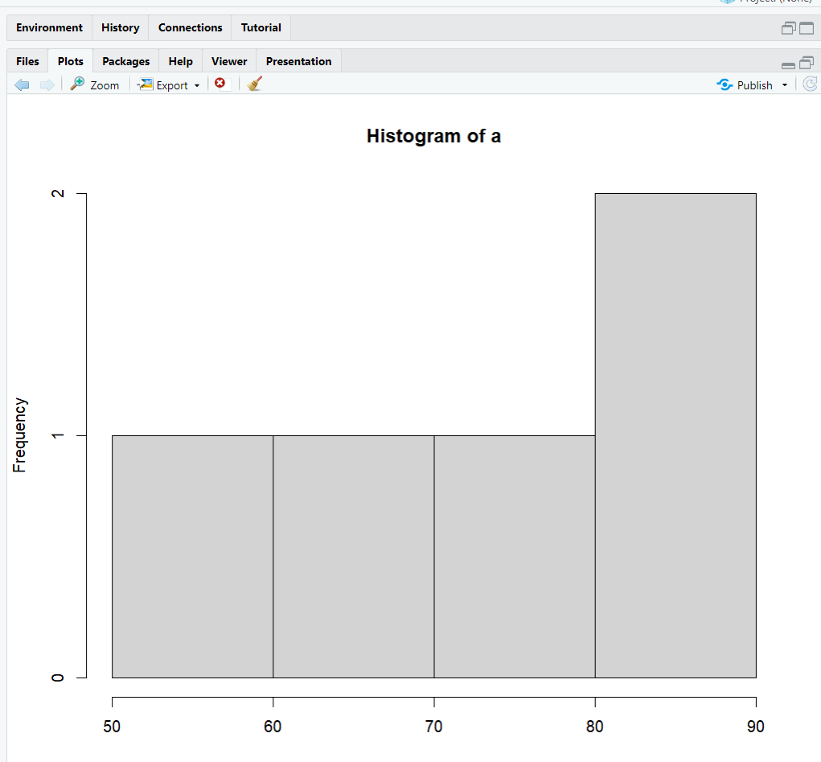

EXPERIMENT – 17 CORRELATION ANALYSIS:
AIM:
To write the program for correlation analysis using R-tool.

PROGRAM:
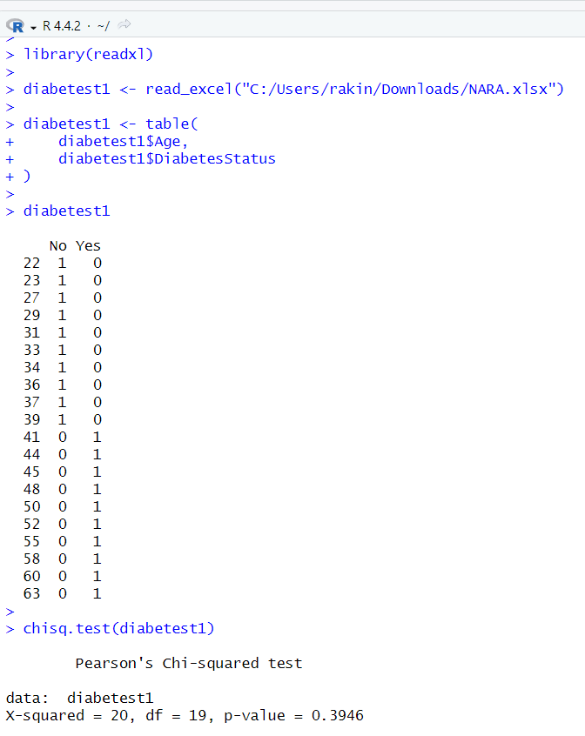

EXPERIMENT – 18 SCATTER PLOT
AIM:
To draw the scatter plot using R-tool.

PROGRAM:
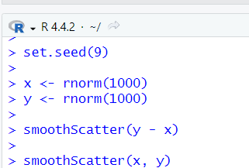
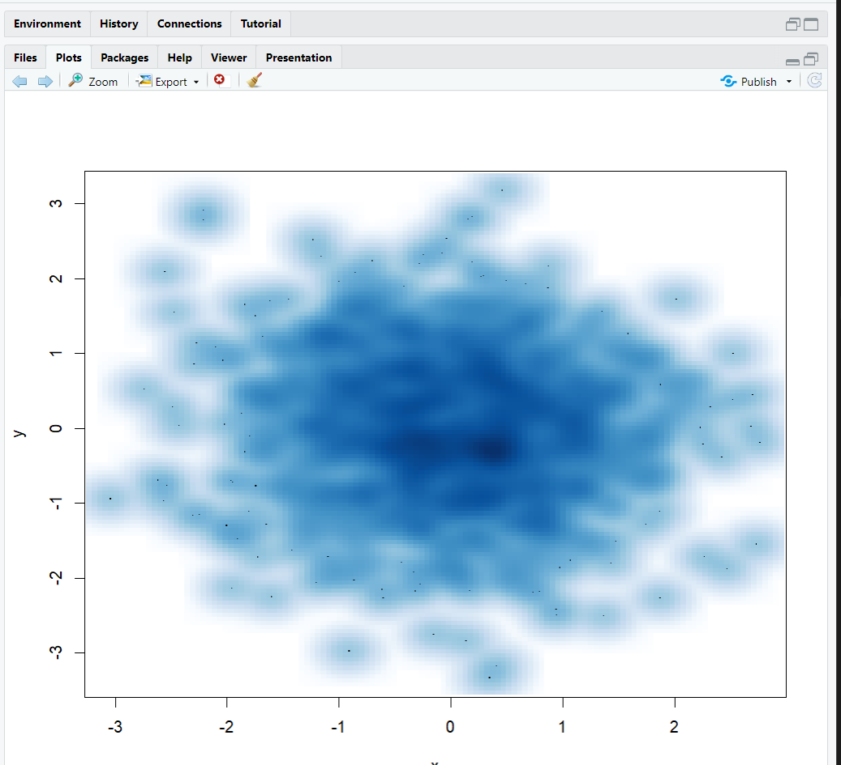

EXPERIMENT – 19 LINEAR REGRESSION
AIM:
To write a program for linear regression using R-tool.
PROGRAM:
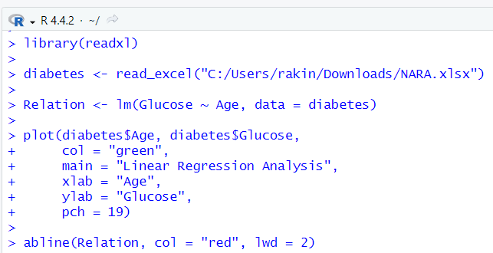
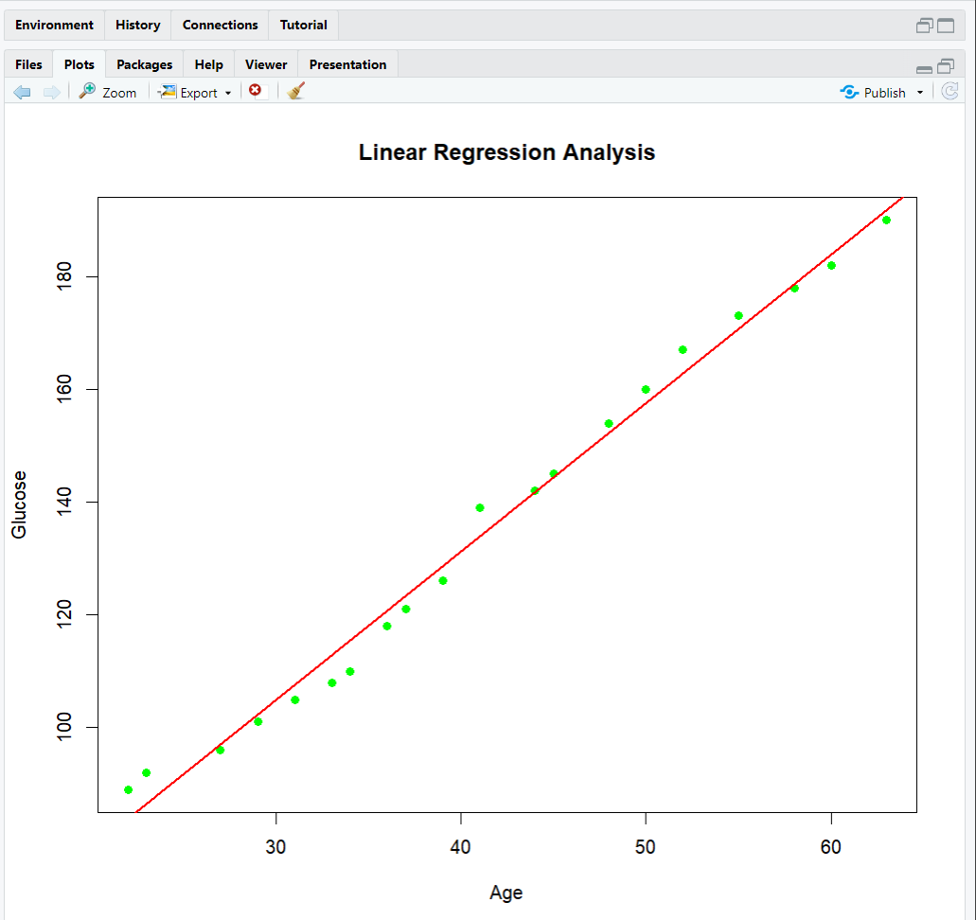
EXPERIMENT – 20 MULTIPLE REGRESSION
AIM:
To write a program for multiple regression using R-tool.

PROGRAM:
